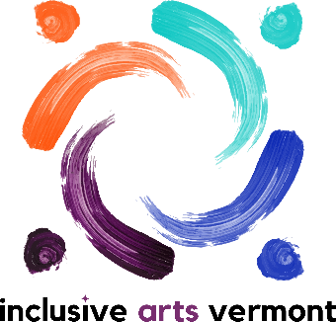
Inclusive Arts Vermont Exhibitions and Accessibility
Int ernship Job Description
Fall 2024

Inclusive Arts Vermont Mission Statement: Inclusive Arts Vermont uses the magic of the arts to engage the capabilities and enhance the confidence of children and adults with disabilities.
Accountability/Supervisor: Heidi Swevens, Director of Community Partnerships and Exhibitions
Dates: September – December 2024
Schedule and Times: The internship schedule will be a blend of remote and in-person activities. The schedule will be developed by the intern prioritizing school. The schedule will be communicated with the IAV team. Interns meet regularly with supervisor and staff connected to projects/exhibitions. Hours required vary depending on the program. Flexible to meet student academic goals.
Position Summary: Exhibitions and Accessibility Interns assist the Inclusive Arts Vermont team with aspects of the Exhibitions Program and accessibility features throughout programming. Intern’s primary responsibility is to build their professional learning. They will be involved in a mix of project specific assignments, general admin, and independent research/interests that connect with IAV mission and goals.
Primary Functions:
- Attend staff and individual meetings when possible/relevant.
- Complete onboarding, orientation, and ongoing admin (timesheets, supervision, etc.).
- Learn about the CYCLES Exhibition, artists, accessibility features, venues, and tours.
- Participate in in-person programs when possible – particularly at UVM’s Center on Disability and Community Inclusion for the close of the exhibition tour.
- Assist with providing accessibility features like verbal description, social stories, transcript development, and more.
- Provide transportation and sighted guide when applicable.
- Maintain clear communication with Inclusive Arts Vermont Exhibitions team, management team, artists and others.
- Maintain confidentiality of participants and programs.
- Represent the organization in a manner that inspires public confidence, models Inclusive Arts Vermont’s mission, and contributes to excellence and accountability.
- Other duties as assigned
Secondary Functions:
- Supporting Adult Arts Education classes with presence at classes, printing and gathering goal sheets, evaluations, and certificates, and supporting teaching artists as needed.
Qualifications:
- Experience with and openness to diverse groups of people
- Appreciation for the arts and creative processes
- Quality communication skills
- Ability to use and/or learn to use digital technology
- Ability to take direction, work independently, and collaborate as part of a team
- Valid driver’s license or access to reliable transportation
- Sensitivity and respect for Inclusive Arts Vermont’s mission

