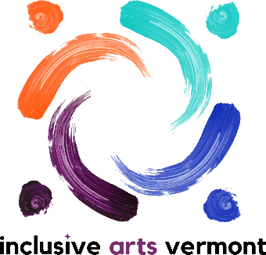

Inclusive Arts Vermont Adult Arts Education and Accessibility
Internship Job Description
Spring 2024
Inclusive Arts Vermont Mission Statement: Inclusive Arts Vermont uses the magic of the arts to engage the capabilities and enhance the confidence of children and adults with disabilities.
Accountability/Supervisor: Heidi Swevens, Director of Community Partnerships
Dates: January – April 2025
Schedule and Times: The internship schedule will be a blend of remote and in-person activities. The schedule will be developed in collaboration. It will coincide with in-person Adult Arts Education classes. The schedule will prioritize school. Interns meet regularly with supervisor and staff connected to assignments. Hours required vary depending on the program. Flexible to meet student academic goals.
Position Summary: Interns with this role assist with aspects of Adult Arts Education residencies and accessibility. Intern’s primary responsibility is to build their professional learning. They will be involved in a mix of program specific assignments with teaching artists. They will supplement that learning with general accessibility and independent projects.
Primary Functions:
- Complete onboarding, orientation, and ongoing admin (timesheets, supervision, etc.).
- Support Adult Arts Education residencies with presence at classes
- Assist teaching artists with set up, clean up, and other aspects of class
- Assist with distribution and collection of goal sheets, surveys, and other documentation
- Learn about and contribute to general access practices at IAV
- Maintain clear communication with Inclusive Arts Vermont teaching artists, IAV staff, and program participants
- Meet regularly with supervisor
- Maintain confidentiality of participants and programs.
- Represent the organization in a manner that inspires public confidence, models Inclusive Arts Vermont’s mission, and contributes to excellence and accountability.
- Other duties as assigned
Qualifications:
- Experience with and openness to diverse groups of people
- Appreciation for the arts and creative processes
- Quality communication skills
- Ability to use and/or learn to use digital technology
- Ability to take direction, work independently, and collaborate as part of a team
- Valid driver’s license or access to reliable transportation
- Sensitivity and respect for Inclusive Arts Vermont’s mission

